No.BB/Colleges/2011-12/Vol-1/1 dt at Chennai-8 the 08-09-2011

To
Heads of SSA (Except CON,DPI,ERD & TT SSAs)
BSNL,TN Circle.

Sub: NMEICT-Universities-Procedure for measuring the traffic-reg.
Ref: DGM(P3-OP & NME) , HYD e-mail to googlegroup dt.07-09-2011.

Kind attention is invited to the above captioned subject. The document for measuring the traffic of universities using eMS of RPR/DSLAM received vide above reference is here with enclosed. Concerned SSAs are requested to verify the link utilization regularly to avoid complaints from the universities. Compliance report in this regard may be sent to this office immediately.

Sd /- Asst.General Manager(BBVAS)
O/o PGM-CFA,BSNL
Tamilnadu Telecom Circle,
Chennai-600 008.

1. Bandwidth Utilization in DSLAM uplinks: This will be useful in assessing the requirement uplink capacity in the DSLAM so that the speed related issues can be resolved. This is required to be checked at regular intervals as the traffic through the DSLAM increases with integrations of WiMAX, provisioning of high speed ILLs, integrations of 3G elements using ports in the broadband network elements.
Following command shows the percentage utilization of capacity of the uplink from the DSLAM of different make.

UTSTAR DSLAM: # show load <uplink port number>
Eg: #show load ge 1
Output of this command gives the %of utilization and actual packet flow at that moment

NSN DSLAMs : # show port statistics avg-pkt <uplink port number>
Eg: #show port stat avg-pkt 0/1

Output of this command gives the actual packet flow at that moment

ZTE DSLAMs:
#show interface <uplink port number> statistics
# show interface 5/1 statistics

Output of this command gives the actual packet flow at that moment

RPR –Traffic-monitoring on the ports using eMS

Steps:
1) login to RPR EMS
2)double click on the T1/T2
3)click on maintanance--Bandwidth occupancy--begin calculate.
4) After 2 minutes you will get current traffic of all the Ports

>>> Log in to RPR-> go to concerned ring

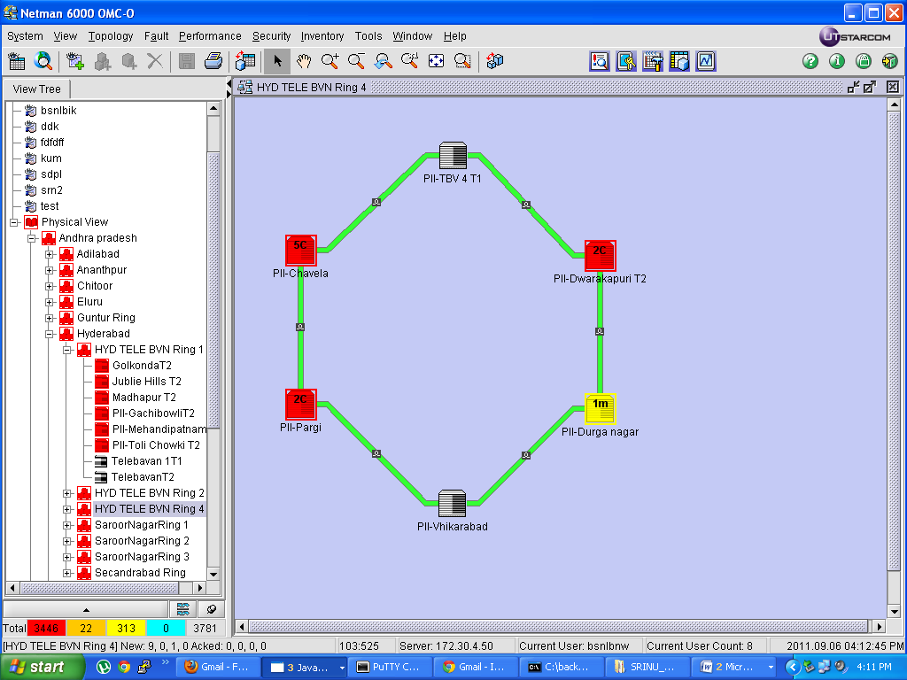

>>> Double click on concerned teir and go to Maintenance and click on Bandwidth Occupancy

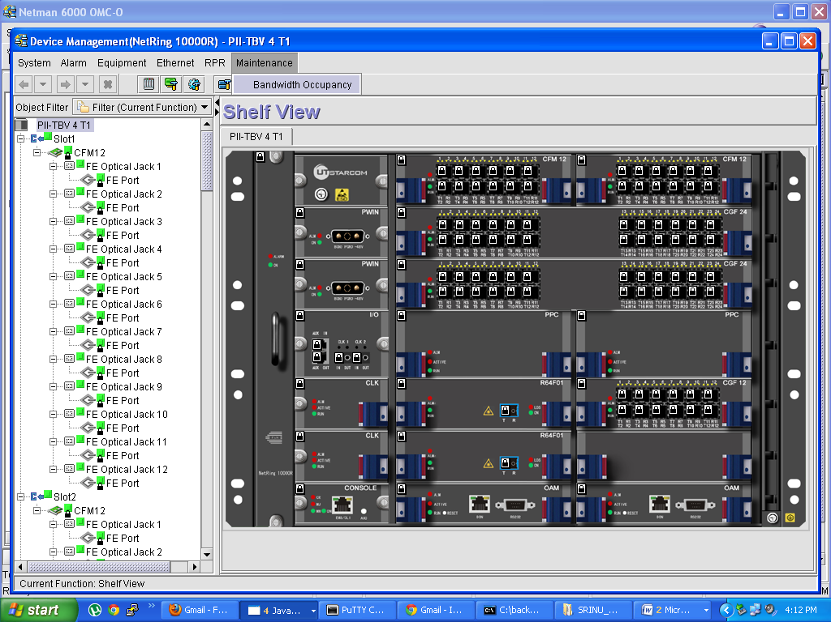

>>> Now click on Begin calculate : After 2mins Results will be displayed as:
